Problem Statement & Website Description
The website being designed, The Gentle Space, is a purpose-built digital wellness platform centered on three highly accessible practices: Yoga (Movement), Meditation (Stillness), and Laughter Yoga (Emotional Release). The fundamental problem it addresses is the digital friction and decision fatigue that undermines user consistency in self-care. Most existing wellness apps either specialize narrowly (e.g., only meditation) or offer an overwhelming number of choices, causing stressed users to abandon their journey before it begins. The Gentle Space solves this by providing a curated, anti-anxiety ecosystem. Its main idea is to use an integrated approach to offer rapid therapeutic choices that cover the entire stress-relief spectrum; physical tension, mental chatter, and emotional stuckness - all within one comforting, easy-to-navigate interface.
The primary intended users are high-functioning, digitally fatigued adults and young professionals (ages 25-45) who urgently need effective stress and anxiety management tools but lack the time or mental capacity to shop for multiple solutions. Their core goals are highly actionable: finding and completing a session tailored to their immediate emotional state (e.g., an instant Laughter Yoga release when frustrated), building a sustainable daily habit (e.g., 10 minutes of morning meditation), and booking specialized, gentle live classes (e.g., Restorative Yoga). To support these goals, the site must provide crucial, transparent information: a single, filterable content library and calendar, concise session descriptions highlighting the immediate therapeutic benefit (e.g., 'Reduces Cortisol in 5 minutes'), clear practitioner credentials, and abundant testimonials that reinforce the platform's focus on non-judgmental, gentle care.
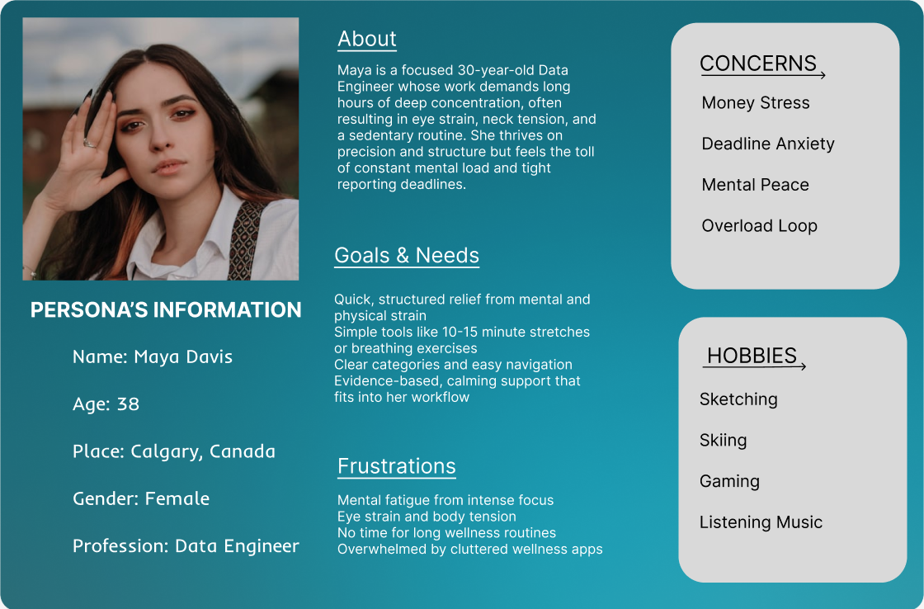
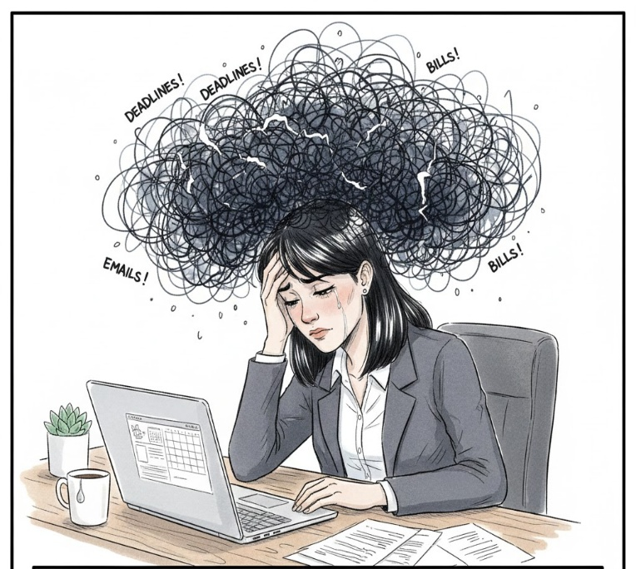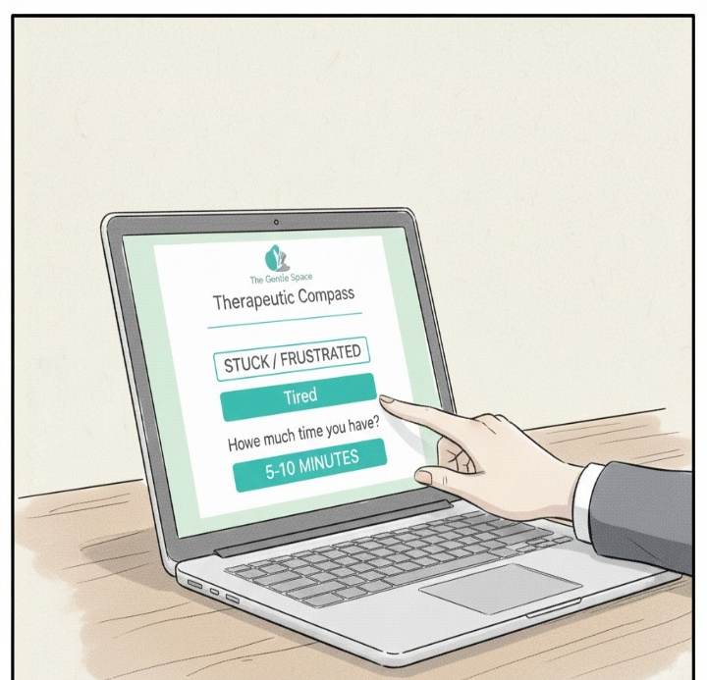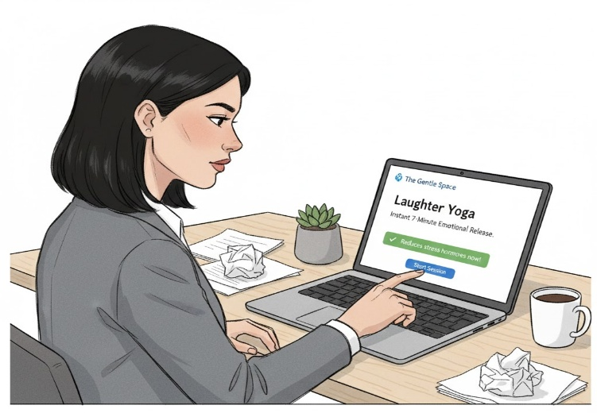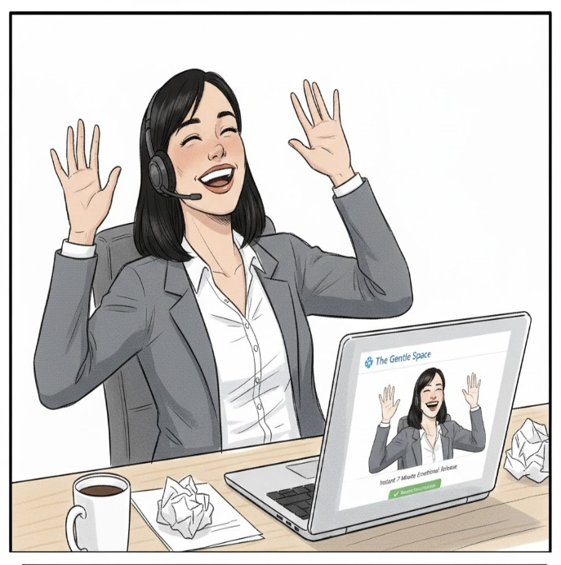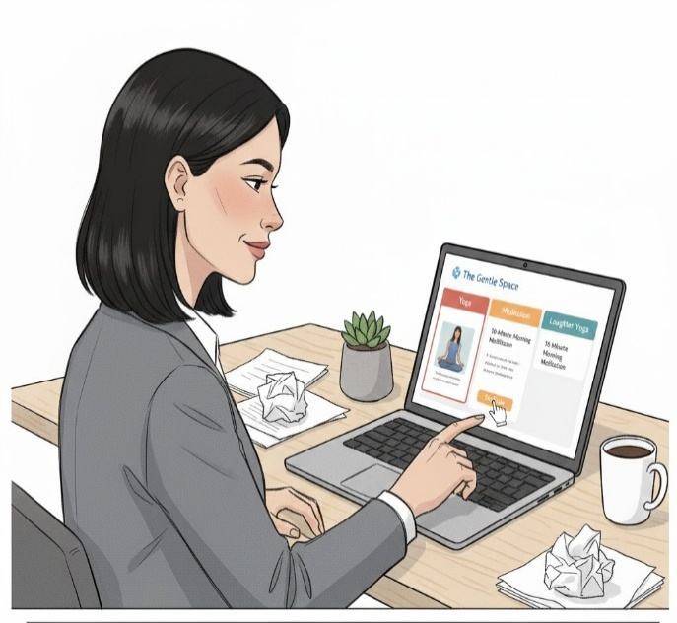
The platform instantly recommends a Laughter Yoga session, a practice Maya knows is great for immediate emotional release. The concise, targeted information removes all doubt.

She remembers The Gentle Space - the platform promising all-in-one relief. She logs in, seeking the comforting interface that won't punish her mental fatigue with complexity.
With her emotional state reset, Maya uses the calm interface to browse the other pillars. She easily schedules a 10-minute meditation for tomorrow morning, committing to her sustainable routine

Maya dives into the session. The focused Laughter Yoga session provides the physical and energetic release she desperately needed, interrupting the negative emotional feedback loop.
She remembers The Gentle Space—the platform promising all-in-one relief. She logs in, seeking the comforting interface that won't punish her mental fatigue with complexity.
Maya feels trapped and emotionally stuck after a tough meeting. She urgently needs a release, but the thought of opening three different apps feels impossible.

Home Page
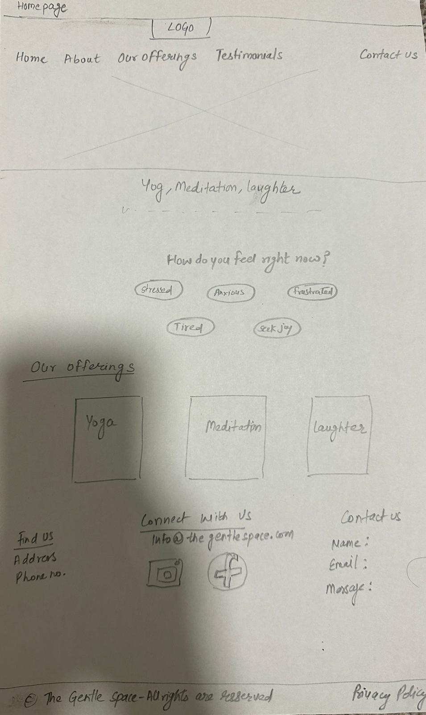 | Clicking on ‘Our offerings’ button at the top will navigate to Our offerings on this page.  Clicking on ‘Contact us’ button at top will navigate to the contact us in the bottom section.  After picking an option from how you feel right now? will help picking service  The Gentle Space logo,  Home, About, Our offerings, Testimonials and Contact us tab at the top will displayed on all the pages.  Find us, connect with us, contact us and footer (all rights reserved and privacy policy) will be displayed on all the pages.  Clicking on ‘Home button’ will always return the user to the home page  This is the page the users see when the page is opened. The call-to-action page.

 | 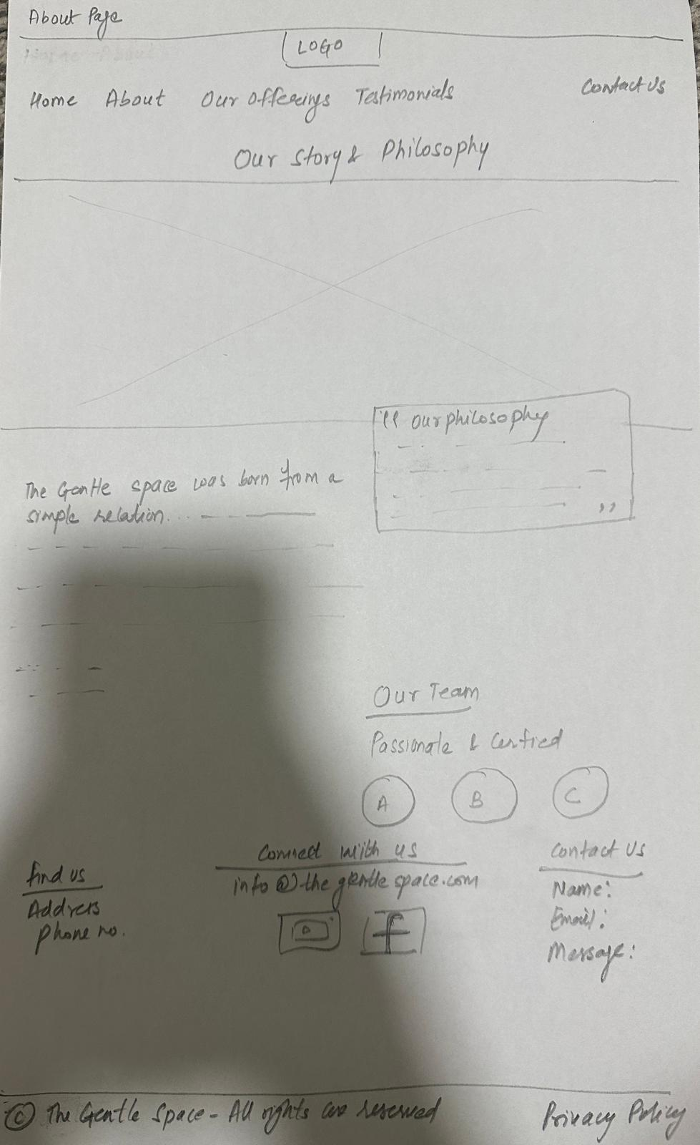 | This page shows the Philosophy and the Team of ‘The Gentle Space’.  Clicking on the ‘About’ button will take the user to the About page
Clicking on the Home button will always return users to the Home page
Home Page About Page
Home Page Testimonials Page
Clicking on the Home button will always return users to the Home page
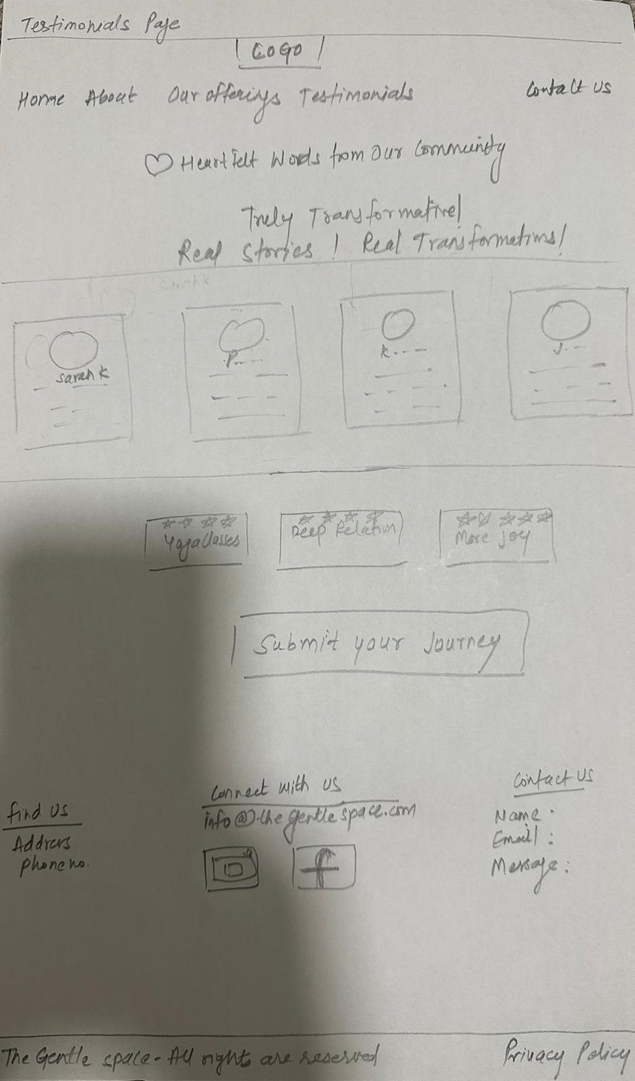
Clicking on ‘Testimonials’ button will take the user to the testimonials
Testimonials page has true transformation journey of the clients and ‘submit your journey’ button.

